

**GROUP TASK COVER SHEET**

|  |  |  |  |  |  |  |  |  |  |
| --- | --- | --- | --- | --- | --- | --- | --- | --- | --- |
| *Students*  *Please sign, date and attach cover sheet to front of written assessment task OR*  *submit as a separate document for non-written assessment task.*  *A cover sheet is to be completed for each assessment task.* | | | | | | | | | |
| **SUBJECT CODE** |  | | | | | | | | |
| **STUDENT FAMILY NAME** | **Student Given Name** | **JCU Student Number** | | | | | | | |
| 1. Lutz | Frederike Pia | 1 | 3 | 3 | 8 | 6 | 4 | 9 | 4 |
| 1. Malkannagari | Udaya Bhaskar Reddy | 1 | 3 | 3 | 6 | 8 | 1 | 7 | 1 |
| iii. |  |  |  |  |  |  |  |  |  |
| iv. |  |  |  |  |  |  |  |  |  |
| v. |  |  |  |  |  |  |  |  |  |
| vi. |  |  |  |  |  |  |  |  |  |
| **ASSESSMENT TITLE** | Design Thinking Challenge – Assessment Task 1 Project Plan | | | | | | | | |
| **DUE DATE** | 02.09.2016 | | | | | | | | |
| **LECTURER NAME** | Randy Zhu | | | | | | | | |
| **TUTOR NAME** | Randy Zhu | | | | | | | | |
| **Student Declaration**   1. This assignment is our original work and no part has been copied/ reproduced from any other person’s work or from any other source, except where acknowledgement has been made (see *Learning, Teaching and Assessment Policy 5.1*). 2. This work has not been submitted for any other course/subject (see *Learning, Teaching and Assessment Policy 5.9*). 3. This assignment has not been written for us. 4. We hold a copy of this assignment and can produce a copy if requested. 5. This work may be used for the purposes of moderation and identifying plagiarism. 6. We give permission for a copy of this marked assignment to be retained by the College for benchmarking and course review and accreditation purposes.   [Learning, Teaching and Assessment Policy](http://www.jcu.edu.au/policy/allitoz/JCU_076643.html) 5.1. A student who submits work containing plagiarised material for assessment will be subject to the provisions of the [Student Academic Misconduct Requirements.](http://www.jcu.edu.au/policy/allitoz/JCUDEV_005375.html)  **Note definition of plagiarism and self plagiarism in Learning, Teaching and Assessment Policy:**  **Plagiarism:** reproduction without acknowledgement of another person’s words, work or expressed thoughts from any source. The definition of words, works and thoughts includes such representations as diagrams, drawings, sketches, pictures, objects, text, lecture hand-outs, artistic works and other such expressions of ideas, but hereafter the term ‘work’ is used to embrace all of these. Plagiarism comprises not only direct copying of aspects of another person’s work but also the reproduction, even if slightly rewritten or adapted, of someone else’s ideas. In both cases, someone else’s work is presented as the student’s own. Under the Australian Copyright Act 1968 a copyright owner can take legal action in the courts against a party who has infringed their copyright.  **Self Plagiarism:** theuse of one’s own previously assessed material being resubmitted without acknowledgement or citing of the original. | | | | | | | | | |
| **Student signature(s)**  i.…Frederike Lutz………………… Submission date …02../…09../ 2016 iv……………………… Submission date ……../……../ 2015  ii………………………………………… Submission date ……../……../ 2015 v ……………………… Submission date ……../……../ 2015  iii………………………………………… Submission date ……../……../ 2015 vi……………………… Submission date ……../……../ 2015 | | | | | | | | | |

# DESIGN THINKING PROJECT

**ASSESSMENT TASK 1**

**Project Plan**

Sustainability Project

* Carpooling or public transport enabling apps

Smart cities

In this globalized and digitalized world, we live in nowadays, a world which primarily focuses on being successful, achieving (self-) set goals and constantly improving oneself, it is crucial for our surroundings to work effectively and efficiently, to simply function. One tends to expect certain aspects of life to be there and work smoothly if needed, without putting too much effort or thoughts into it while tending to a busy lifestyle. No one wants to waste valuable time waiting for overcrowded trains, in which you get to know your fellow commuters way better than you intended to, being trapped in a traffic jam or looking for a parking space. Traffic systems, especially in countries which are rather small and highly populated (only Monaco has a higher population rate per square kilometer) and an island, are at stake to be highly sophisticated, cleverly thought through and on point.

In the age of the Internet of Things, really ‘smart’ smart phones and technology developing at an almost fast-as-lightning rate, a great amount of opportunities come into being to constantly improve traffic systems to accommodate the growing needs and expectations they are being faced with every day.

In the means of determining the scope of this project, primary and secondary research has been conducted and several main problem areas have been identified.

The Singaporean traffic system (in the further context ‘traffic system’ includes trains (MRT), buses, taxis and cars) is being perceived as being highly efficient and satisfying as it is. Anyhow, there always is room for improvement. Since the existing traffic system is generally perceived as being sufficient most of the time, this project is mainly going to concentrate on the traffic enabling apps which surround the traffic system and aim to improve the travelling experience.

A main issue is the crowdedness of not only the MRT trains but the stations as well. It is a hassle to lose precious time one could have spent at home with the family, at school or work, missing a meeting, time which could have been used effectively, because the stations are too crowded during rush hour and access to the trains is impossible. To enhance the existing traffic apps with a feature which provides information about the state of the crowdedness (e.g. a “traffic light system”), not only during rush hours, but throughout the day, would be relatively simple (e.g. through motion-sensitive sensors in th

Creating such simple, user-friendly mobile applications will open up many new possibilities and transform how we live and work, making sustainable living more accessible than ever.

|  |  |  |
| --- | --- | --- |
| Name: | Student ID: | Roles: |
| Udaya Bhaskar Reddy Malkannagari | 13368171 | Team leader |
| Frederike Pia Lutz | 13386494 | Minutes meeting taker |
| Cecilie Chen | 13369768 |  |
| Robert Harkov |  |  |
| James |  |  |

1. Preliminary project meeting schedule:

|  |  |  |
| --- | --- | --- |
| Meeting | Plan | Objectives |
| 1 | 22.08.2016 3 p.m. JCU Student HUB | Collect interviews and empathy maps and decide on a specific topic. Start working on the project plan. |
| 2 | 29.08.2016 12 p.m. JCU Student HUB | Collect everybody’s research and consolidate the individual’s work of the project plan. |
| 3 | 02.09.2016 11 a.m. JCU Student HUB | Finish the project plan, collect the minutes meetings, everybody’s interviews and empathy maps to upload everything at Learn JCU. |

1. Electronic Signatures:

|  |  |  |
| --- | --- | --- |
| Name: | Signature | Date |
| Udaya Bhaskar Reddy Malkannagari | Udaya Bhaskar | 01.09.2016 |
| Frederike Pia Lutz | Frederike Lutz | 01.09.2016 |
| Cecilie Chen | Cecilie Chen | 31.aug. 2016 |
| James |  |  |
| Robert Harkov |  |  |

By signing electronically means that it has been understood that it is the same as handwritten signature, written and approved by the owner of the name.

**Team Meeting Minutes Template 1**

Name of Team: Design Thinking 2016

Date of Meeting: 22.08.2016 Start Time: 3 p.m. Finished Time:

Members present: Frederike Pia Lutz, Udaya Bhaskar Reddy

Members absent: Cecilie Chen, Robert Harkov, James

Meeting Chairperson: Udaya Bhaskar Reddy

Minutes taken by: Frederike Pia Lutz

Summary of Meeting: Since three group members were missing and didn’t cancel, the meeting was postponed to 23.08.2016

Actions for Team members:

|  |  |  |
| --- | --- | --- |
| Actions to do | Who will do this work? | By When? |
| ./. | ./. | ./. |
| ./. | ./. | ./. |
| ./. | ./. | ./. |

Next Meeting Date: 23.08.2016

Next Meeting Time: 12 p.m.

Meeting chairperson sign to approve of this meeting minute:

Name: Signature: Date:

**Team Meeting Minutes Template 2**

Name of Team: Design Thinking 2016

Date of Meeting: 23.08.2016 Start Time: 12 p.m. Finished Time: 12.15 p.m.

Members present: Frederike Pia Lutz, Udaya Bhaskar Reddy, James, Robert Harkov

Members absent: Cecilie Chen

Meeting Chairperson: Udaya Bhaskar Reddy

Minutes taken by: Frederike Pia Lutz

Summary of Meeting: Since, again, not everybody was there and most of the group members didn’t complete the assignments, it was postponed to Monday, 29.08.2016

Actions for Team members:

|  |  |  |
| --- | --- | --- |
| Actions to do | Who will do this work? | By When? |
| Research on smart cities | Everybody | Next meeting |
| Conduct interview | Everybody | Next meeting |
| Empathy map | Everybody | Next meeting |

Next Meeting Date: 29.08.2016

Next Meeting Time: 9 a.m.

Meeting chairperson sign to approve of this meeting minute:

**Team Meeting Minutes Template 3**

Name of Team: Design Thinking 2016

Date of Meeting: 29.08.2016 Start Time: 9 a.m. Finished Time: 12.15 p.m.

Members present: Cecilie Chen, Udaya Bhaskar Reddy, James, Robert Harkov

Members absent: Frederike Pia Lutz (sick)

Meeting Chairperson: Udaya Bhaskar Reddy

Minutes taken by: Udaya Bhaskar Reddy

Summary of Meeting:

Actions for Team members:

|  |  |  |
| --- | --- | --- |
| Actions to do | Who will do this work? | By When? |
| Research on smart cities | Everybody | Next meeting |
| Conduct interview | Everybody | Next meeting |
| Empathy map | Everybody | Next meeting |

Next Meeting Date: 30.08.2016

Next Meeting Time: 3 p.m.

Meeting chairperson sign to approve of this meeting minute:

**Team Meeting Minutes Template 4**

Name of Team: Design Thinking 2016

Date of Meeting: 30.08.2016 Start Time: 11 a.m. Finished Time: 12 p.m.

Members present: Frederike Pia Lutz, Udaya Bhaskar Reddy, Robert Harkov, Cecilie Chen

Members absent: James

Meeting Chairperson: Udaya Bhaskar Reddy

Minutes taken by: Frederike Pia Lutz

Summary of Meeting: Final discussion of the updated Assignment 1, no further concerns / issues or problems issued by the other team members, not in person nor via email / text. The final document has been on the drop box since Thursday night, everybody was informed about that in the last meeting and in an additional notification via text. Everybody had enough time to make changes or start a discussion, since nobody did it shall be deemed as accepted by everybody.

The plan for Assignment 2 has been briefly explained by Frederike Pia Lutz to the other team members. Each member is to be assigned a task at the next meeting, this will be documented and each member is responsible for the completion of his or her part.

Actions for Team members:

|  |  |  |
| --- | --- | --- |
| Actions to do | Who will do this work? | By When? |
| Read through Assignment 2, make notes and first ideas how to approach this task as a group. Start individual work already. | Everybody | Next meeting, Tuesday 06.09.2016 2 p.m. |
| Upload Assignment 1 with all its attachments | Frederike Pia Lutz | Friday, 02.09.2016 5 p.m. |
|  |  |  |

Next Meeting Date: 06.09.2016

Next Meeting Time: 2 p.m.

Meeting chairperson sign to approve of this meeting minute:

Name: Signature: Date:

**Research notes, interview notes and insights Template**

**By Robert Harkov:**

How do Yandeks.Probki

Yandex shows users a picture of the traffic congestion. For this service collects data from various sources on the streets of congestion, analyzes it and displays On Yandex.Maps. In most large cities where traffic jams - a serious problem, not just a nuisance, the service calculates the score jams - the average level of congestion. To understand how it works Yandeks.Probki, consider all the way - from the actual traffic situation on the road to its image in the service. service technology is designed so that the traffic information is collected including the users themselves. That is to say that drivers are helping drivers to avoid traffic jams.

**data Sources**

To visualize what we are - an accident on the boulevard in front of Strastnom Petrovka (small and without sacrifices). His appearance, we blocked, for example, two rows of the existing three. Motorists who moved in our ranks, we have to go around, and drivers are moved to the third row - skip making the rounds. Some of them - users and applications Yandex Yandeks.Navigator and their mobile devices is transmitted Yandeks.Probki data on driving. As users of these machines closer to our accident their speed will be reduced, and the device will start to "inform" the service of the mash.

To participate in the data collection, motorists are required: internet access phone or tablet with a GPS-receiver and installed on the device or application Yandeks.Navigator Yandex enabled "to report traffic jams" mode. Every few seconds, the device transmits its geographic coordinates, direction and speed of the computer system Yandex.Probki. All data are impersonal, ie not contain any information about the user or his car. Then, the program analyzer builds a single traffic route with information about its speed of passage - a track. Tracks come not only from private drivers, but also from vehicles of partner companies Yandex (organizations with a large fleet of vehicles plying on the city).

In addition to its coordinates motorists can report service additional information about accidents, repairs or other road troubles. For example, some conscious driver, see our accident, he warned him of other motorists by putting the appropriate point in the mobile Yandex.Maps.

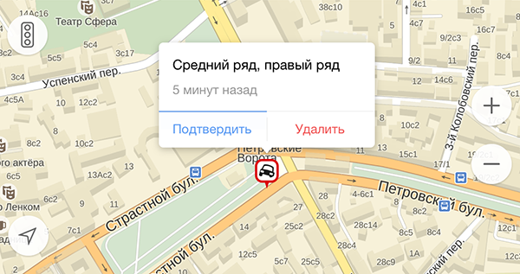

**tracks Processing Technology**

GPS-receivers allow for error in determining the coordinates, making it difficult to track construction.Accuracy can "shift" the car a few meters in any direction, for example, on the sidewalk or the roof of a nearby building. The coordinates received from the users get on the electronic circuit of the city, on which very accurately displayed all buildings, parks, streets with road markings and other city facilities. With this drill program understands how to actually move the vehicle. For example, in the locality of the machine is not able to go to the oncoming lane or turn has been made on road markings, do not "cut" corner.

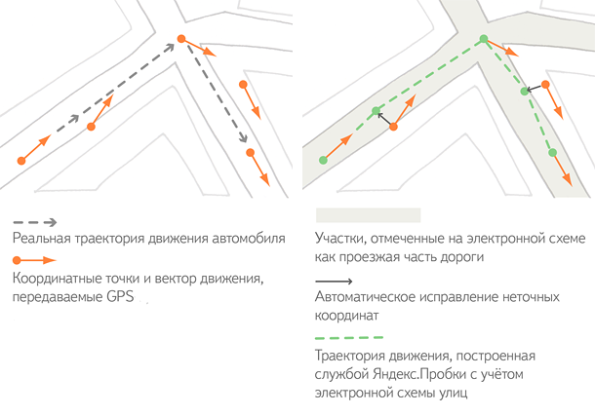

In order to properly recreate the picture of traffic congestion, it is necessary to check whether the situation corresponds to the track on your site. Users of mobile Yandex.Maps can sometimes stop or slow down the movement is not due to the traffic jams, and, for example, to buy something at a kiosk or unobtrusive not miss a turn. And if by free riding several cars with mobile devices, this track will be deselected algorithm because it does not reflect the actual workload of the site. Therefore, the more people are in service, the more precise information about the traffic situation.

After combining proven track algorithm analyzes them and exposes the "green", "yellow" and "red" assessment of the relevant sections of roads.

**Combining data**

Further there is aggregation - the process of combining information. Every two minutes aggregator collects, like a mosaic, the information received from users of mobile Yandex.Maps in one scheme. This pattern is drawn on a layer of "Jam" Yandex.Maps - and in the mobile application and web service.

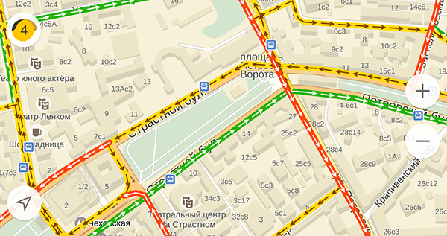

**Scale of points**

In Moscow, St. Petersburg and other major cities Yandeks.Probki service assesses the situation on the 10-point scale (where 0 points - the free movement and 10 points - the city of "costs"). With this assessment, drivers can quickly figure out approximately how much time they will lose in traffic jams. For example, if the average score in Kiev is seven, the road takes about two times longer than in free motion.

Scale scores configured differently for each of the cities that in Moscow - a glitch in another city - has a serious traffic jam. For example, in St. Petersburg, with six points driver to lose about the same time as even at five in Moscow.

Points are calculated as follows. In the streets of every city in advance compiled routes, including the main highways and avenues. For each route there is a reference time during which it is possible to drive on the open road without breaking the rules. After assessing the overall workload of the city aggregator program calculates how many different real time by reference. On the basis of the difference on all routes and the calculated load in points.

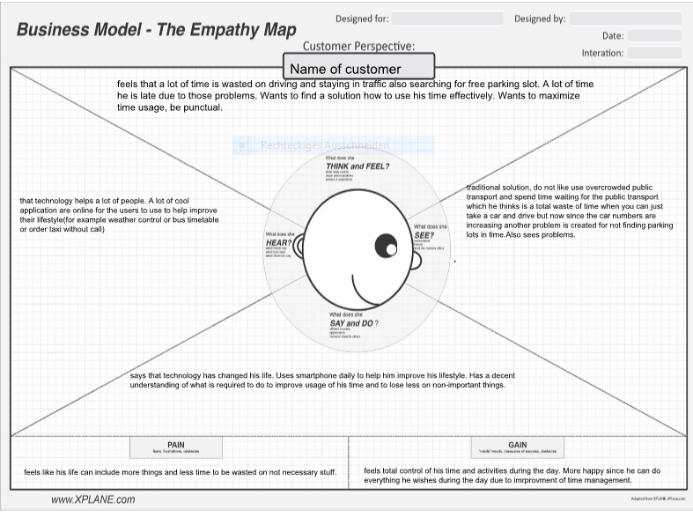

**Interview**

Name Nikita

21 years old

Master Diploma IT Student

1.Hi, how are you? You are not local, aren't you?

yes i am, i came from Russia

What brought you here? 2. ambitions and goals for becoming more successful and receiving a better education.

Can you tell me a bit about yourself, background, plans, ambitions? 3. i want to be the best at my profession, i am studying finances and i believe i can become successful and do what i love: is making money

4.It seems you have been in many places and countries, but why have you chosen Singapore? this city is very active and dynamic, also the atmosphere of work and wealth motivates me to work harder to reach success

5.What are you going to change if in power ,.....in infrastructure, education, health care, social services, public transport, enviromental issue.... at my city in Russia, St.Petersburg i will change infrastructure to more modern, social services must be improved but since my country is corrupt most of the budget goes where it is not supposed to, also maybe putting price higher on cars like singapore would work to improve traffic and atmosphere, but i love my city.

6. how to improve, rebuild, implement without destruction, to use previous experience? it is rather difficult to change the city after it is built, it would be nice if a new city would be built or invested in to make a good balanced city with everything included to make it a smart city

7. Singapour undoubtedly one of the most attractive cities in the world, so called Smart City. Is it so smart to any person? yes, i see no traffic, not so many cars, a lot of easy accessible public transport, air control and weather control is also present.

8. Don't you think that technology is being developed much faster than people? How to narrow the gap between privileged and unprivileged.Even a Smart City has its down town and outskirts. I believe not all 7 billion people in the world can be lucky enough to be raised or live in the smart city, some countries are poorer, some are richer. Singapore is a smart city because a lot of money was invested in, for example Warsaw or Riga does not have such finances like singapore since the country it self is not rich. Maybe EU can make a rule to include technology in their cities to attract tourists and make the city more livable.

9.Will be ever solve a huge problem of our days, this industrial and technological progress and as consequences... pollution, climate change? no it won’t, we live in the days of human consumption which is rather hard to change, no one will stop driving cars and if you think using ecological electrical cars is the solution you are wrong, electricity is made in very dirty and pollutive way which doesn’t solve the problem, no one will stop using their phones or computers which is electricity also, mostly in developed country every person has a phone which is being charged every day and used massively, a lot of lights are used at night when everyone are sleeping, if you see from airplane window when you fly at night all city is in lights which is not required since most people at 3 am are sleeping.

10.How to be successful and also responsible in a long a short terms?

work hard, listen to advices, use technology in a useful way, because sometimes it can be addiction or harmful. Read daily news to be aware what is happening for example you saw the smog on the streets, at first i thought it was a fog but in reality is was a smog from Indonesian forest fires which is very dangerous, it was purple on the scale, brown is most dangerous for health and purple after. I wouldn’t know what it was until i read the local news, there was similar smog in the summer in Moscow. if you breath it in some parts you inhale from smog are going to stay in your lungs for a long time maybe even whole life. So be self-aware and hard working.

11. What problems do you see in lifestyles in St.Petersburg?

i see that budget of the government is not used correctly (corruption) also that there is a lot of traffic, since the city was built a long time ago the designers couldn’t predict such a technological advancement and also cars in such a big amount. Most of families have 1 or 2 cars for male and female since their works are different and without car in the big city is rather difficult. A lot of people are not comfortable in public transport. Mostly in Russia people who use public transport are not rich enough to afford a car or are in a big hurry.

12. What would you improve to make lifestyle in St.Petersburg better?

create a cheaper public transport to attract more users, make taxes on cars higher so people won’t buy cars as much which will partially solve some traffic since not everybody are wealthy. It is rather difficult to rebuilt city by SmartCity rules

13. I heard parking in big Russian cities is a big problem, a lot of people park on pedestrian zone since they are not comfortable leaving their car far or in a place which is not visible.

Yes it is true a lot of problem with it, a lot of time there is a 2 lanes on one side of the road but only one is used since people park or wait on the driving lane which causes traffic but all parking slots are full

14. So what can government do to improve life of the drivers?

Maybe try to build big parking lots underground of just a building which are secured and easy accessible in areas of the city where people work. Make paid parkings since not all people are willing to pay for all working day park. I think it requires a lot of financing but the outcome will be worth it since drivers will be more pleased and less time will be wasted. Also maybe someone can create a general application where the a big parking lots have a detector which says whether the parking place is filled or empty. It is done in Monaco as far as I know that they say how many spaces are free on all parking, so someone can integrate that to the application and tell which parking is available and how many spots there are available on their mobile devices. Everyone have mobile devices now and everything nowadays is about technology.

Thank you nikita for the brief interview for my design thinking class. Goodbye robert.

**Research**

In the XXI century, the state of the urban environment is determined not only by the presence of infrastructure, that is, material resources. Clever city need smart solutions that provide high quality new development.

Smart City - is the provision of modern quality of life through the use of innovative technologies that provide cost-effective and environmentally friendly use of the city's life support systems.

Smart City - a smart management, smart living, smart people, smart environment smart economy, smart mobility.

**Energy efficiency in the "Smart City"**

Efficient use of energy resources - achievement of economically justified efficient use of energy resources at the existing level of engineering and technology, and compliance with the requirements of environmental protection.

Energy efficiency - using less energy to provide the same level of energy supply of buildings or industrial processes.

**Healthcare in the "Smart City"**

"Smart Health System" - one that leverages the information, analyzes it, and quickly applies the detail, using electronic data integration system for patients. This will reduce the number of medical errors and to increase the effectiveness of treatment. There must be established a permanent exchange of information so that any doctor could access the full relevant medical history to address him patient and find the right therapy faster.

The use of high-tech advanced medical equipment will allow doctors automatically, in real time, to receive accurate information about patients, and therefore individual approach to each patient, choosing the best method of treatment.

**Vehicles in the "Smart City"**  
Vehicles "smart city" is based on the intelligent transport system. This means the integration of operational management of all modes of transport and the ability to respond to events in real time. It is important that the transport system is an integral part of the entire system of "smart city", and therefore should have a user-friendly interface.

The main innovation of the "smart city" in relation to transport - is the creation of the city, pedestrian-oriented and striving to reduce the use of private vehicles to a minimum. Therefore serious attention in the transport system is given to public transport.

Of great importance in the intellectual transport system is the presence of a single transport interface, based on the needs of residents and visitors smart city within which you can find and use a variety of services - from tips on how to drive the car parking to the arrival of the date of the local public transport warning.

**Green planet in the "Smart City**"

Older, non-technological economy formed around him uncomfortable and dirty city, where the best places are given industrial objects, the worst - residents born to these objects serve. On the other hand, the staff is so innovative economy makes high demands on the quality of the habitat that is the source of an increasing demand for "green" neighborhoods, energy efficient homes, offices and ergonomic bicycle paths.

Ideology and technology to protect the environment - urban invention. These concepts are linked: to invent or organize the production of modern energy-saving mechanisms, it is necessary to think ecologically. Thinking in terms of the future.

Smart City is the first city with clean water and air, green parks, cars which do not leave behind a waste gas, the city in which everyone wants to live.

**Infrastructure in the "Smart City"**

Infrastructure "Smart City" helps utilities, businesses and households to improve the economic efficiency; reduce the burden on the environment; provide comfort and safety of residents and visitors alike.

This is achieved by a system of connections between the modules of transport and engineering systems that create ergonomic control loops, as well as raising awareness and efficiency of urban services. A single network of sensors controls the functioning of the basic life support systems of the city, following the movement of vehicles, monitors the structural elements of buildings, supplies the control towers both visually and statistically processed information.

**Education in "Smart City"**

Distance education and e-learning opened a new world trend - smart education. It is not so much about technology, but about the philosophy of education. Smart education or training smart - a flexible training in a lively and ever-changing educational environment. Maximum availability of knowledge ensures that all information is freely available. In this learning process becomes more interactive with a variety of approaches to the problem.

Smart education - is the transition from passive to active content, on-line. E-learning provides a two-way communication between teachers and students, allows the exchange of knowledge, and it does not matter how far the sides are apart.

**Safety in the "Smart City"**

Safety - the key word in the list of priorities for each person, whether it is personal security, home security or business. Modern research in this topic is not intended to overcome the problems, and their anticipation, as if to anticipate the threat and plan protection, the risks can be minimized.

Talking about safe city, we mean not only the equipment of households and critical urban infrastructure surveillance cameras, but also the organization of safe traffic, the fight against crime situation, information security, anti-terrorist activities, drug addiction, prostitution and pedophilia, the most convenient and safe organization of urban space (roads, parking lots, courtyards, gardens, etc.).

**Extras**  
Also easy accessible WI-FI networks in public places, fast broadband connection which can be connected across the city, fiber connection is also very crucial for the people who are working using internet and offices.

Excuse me for my bad English

**SOURCES the ones I visited didn’t copy from them anything formed an opinion:**

<https://en.wikipedia.org/wiki/Smart_city>

http://www1.nyc.gov/site/forward/innovations/smartnyc.page

<http://www.timesofisrael.com/israeli-companies-to-build-smart-city-in-brazil/>

<https://amsterdamsmartcity.com/projects/faridabad-smart-city>

<http://www.mksmart.org/>

<http://smartcities.gov.in/>

http://international.stockholm.se/globalassets/ovriga-bilder-och-filer/green-it-strategy.pdf

<https://www.youtube.com/watch?v=m45SshJqOP4>

<https://www.youtube.com/watch?v=Br5aJa6MkBc>

**Smart City**

Smart is a very common and widespread adjective in our days. A smart person, a smart outfit always draw attention and envy (sometimes green)

What is a Smart City then? A paradise populated with smart people carefree life, perfect environment social and natural? No problem, no pollution? A fantasy or dream may come true?

A Smart City is a city with developped infrastructure, social system, healthcare, education, high tech, shortly many positive things high living standarts and all these wonders create just smart people. They set high targets and succeeded.

A ruler of Milan in 15-th centuries made his town one of the smartest town in Europe. Among the laws and rules he wrote were many we consider important in21-st century,-to keep streets clean and even how to behave, no bad language!

Ludovico Il Moro was his name and the last 8 years of his life he suffered in captivity in France. Milan was and is and will be a Smart City forever. Let's follow good examples even if they had place many centuries ago!!

What is a smart city?

Smart city is a city which include variety of smart functions which is created or included in the city for making life of the citizen or habitant better and more productive.

What do you see as a perfect smart house? with unlimited beer and chips

What would you include in your smart house except beet and chips?

Auto condition, a coffee maker in bed and breakfast also.

In my country Estonia the SMS paying for parking was introduced

**By Cecilie Chen:**

26/07-16

Interview time: 4:04 pm

Male student. 23 years.

Interview 1:

**Good day, how are you?**

* I’m fine. A little bit tired after the lections.

**Thank you for you participation on this interview. You said that you are tired. Do you have a lot to do in school? Homework?**

* Yes, but not that much. It’s mostly because I didn’t sleep that well last night. It was too hard to wake up, haha.

**I see. What is the first thing you do when you wake up then?**

* Check my phone, and then I tend to lie there for 10 minutes to man myself up to get ready for school and all that.

**Do you eat breakfast at home?**

* Sometimes when I have time. Depends when my classes starts.

**Are you usually in rush before you exit your house?**

* Haha, yes. Every 9 am classes. I almost end up ordering a cab or uber in order to make it to class.

**Oh, all right. The Singaporean public transport is not fast enough?**

* Well, I live far away from town so it takes me 15 minutes to go to the nearest bus station and the MRT – so it much more quicker to take the cab.

**Ok. Very well. Do you often forget something when you go out from your house?**

* Oh lord, yes. I often forget to carry my umbrella and sometimes my keys as well…

**What do you do then?**

* I end up getting all soaked if it rains and I walk back home by the bus or MRT, so I often end up with taking a cab home.

**What about the keys?**

* Our door is auto-lock, and since I live here with my family it’s not a problem. I usually stay in school after school to study or do some assignments. And when I get back home, either my mom or father is already there.

**Sounds good. Thank you for your participation on this interview. Have a nice day.**

**Empathy map, customer perspective:**

|  |  |
| --- | --- |
| Think feel? | Frustrated. Need to get up earlier, remember to bring an umbrella if it rains. Remember to bring all the stuff that is needed for that day – i.e. keys. |
| Hear? | Public transport is cheaper |
| See? | Problems, cannot reach school in time by the public transport. |
| Say/do? | Time is a problem. Need to spend lots of money on cab, goes faster. |
| Pain? | Spend too much money on cabs. If taking the mrt and the bus in a rainy day – will get soaked. |
| Gain? | Remember to wake up earlier, and sleep earlier. |

**Interview:**

**Name:**

**Gender: Female**

**Occupation: Student**

**Age:19**

**How are you? May I know your name and your occupation.**

Jin Xing, student, BBA

**How has life been in Singapore?**

Good

**Where are you from?**

Dingcun , Shanxi Province, China

**What difference do u find in your lifestyle now compared to your native place?**

“I come from a small town. Life moves at a faster rate here. “

**Do u think it is better here in Singapore? If so, Why?**

“In a way it is better. The ease of access to every little thing, the transportation network, the health and hygiene, the unpolluted environment…”

**Can u single out one case?**

“The transportation system is much different from where I come from. We need such kind of networks in the remote parts of china as well. Here I can use an app to check the bus timings and reach to my school on time. It is extremely helpful and saves a lot of time”

**Do u know anything about Smart Cities?**

“yes, I do. Cities where everything is user friendly.”

**Good. In a way Singapore is a good example on the emerging necessity for Smart Cities. Now tht u have mentioned the transport system here, how do u think it can be improved further?**

“I think it works perfectly, but for the cost. If they can make it even more economical for the commuters, it will be a giant step forward. That should include the local train network as well.”

**What other things u will look out in a Smart City?**

“Many other things like improvements in health, hygiene, sanitation. I find a lot of manual garbage dumping bins on the roads. There must be a way to clear them out quickly. If they could use new technology to create an automated system, it will work wonders.”

**Can u elaborate on that please?**

“I am not sure of it. They should link them into a network or something for easy wastage disposal”

**Oh, okay. An interconnected Garbage Disposal Mechanism…good!**

**Do u think of some other improvements, or changes to the existing system…from a personal point of view?**

“There are several other things I can think of. It gets very hard when I go a restaurant and not park my vehicle. We need some kind of apps that can update the parking information.”

**Okay, parking apps…What else?**

“Swimming pool…yes, if I can control the temperature in the swimming pool, it will be helpful. I hate getting into cold water!”

**Me too, can u suggest something else?**

“Hmm, I am lost for ideas now…but my primary focus has always been health and sanitation. And if they can constantly monitor the quality of water, it will save us from a lot of troubles!”

**“ Great, u have come up with some innovative ideas…I am sure in a few years time, everything u desire will be true. Thanks for giving me ur time, Goodbye!”**

“It was good talking with u, Goodbye!”

**Researches:**

<http://www.smart-cities.eu>

<http://smarthomeenergy.co.uk/what-smart-home>

Used these sources to have a better understanding for smart cities and homes, and some ideas to what could be leaded to in the interview.

<https://www.smartthings.com>

*Samsung smart things*. Smart objects that can help you get a smart home.

**Ideas for topics:**

1. Smart clock that makes your day easier to face.
2. Things that are often lost > linked to an app with a chip.
3. App that shows where the traffic is so that people can consider if they weather should take public transport or grab a cab.

**By James:**

**Interview**

Q:Do you hear about what is smart city?

A: Actually not, could you introduce for me?

Q: A smart city is an [urban development](https://en.wikipedia.org/wiki/Urban_development) vision to integrate multiple [information and communication technology](https://en.wikipedia.org/wiki/Information_and_communication_technology) (ICT) and [Internet of Things](https://en.wikipedia.org/wiki/Internet_of_Things) (IoT) solutions in a [secure](https://en.wikipedia.org/wiki/Information_security) fashion to manage a city’s assets – the city’s assets include, but are not limited to, local departments information systems, [schools](https://en.wikipedia.org/wiki/School), [libraries](https://en.wikipedia.org/wiki/Libraries), [transportation systems](https://en.wikipedia.org/wiki/Transportation_system), [hospitals](https://en.wikipedia.org/wiki/Hospital), [power plants](https://en.wikipedia.org/wiki/Power_plant), [water supply networks](https://en.wikipedia.org/wiki/Water_supply_network), [waste management](https://en.wikipedia.org/wiki/Waste_management), [law enforcement](https://en.wikipedia.org/wiki/Law_enforcement), and other [community services](https://en.wikipedia.org/wiki/Community_service). The goal of building a smart city is to improve [quality of life](https://en.wikipedia.org/wiki/Quality_of_life) by using technology to improve the [efficiency](https://en.wikipedia.org/wiki/Efficiency) of services and meet residents’ needs. ICT allows city officials to interact directly with the community and the city [infrastructure](https://en.wikipedia.org/wiki/Infrastructure) and to monitor what is happening in the city, how the city is evolving, and how to enable a better quality of life. Through the use of sensors integrated with real-time monitoring systems, [data are collected](https://en.wikipedia.org/wiki/Data_collection) from citizens and devices - then processed and analyzed. The information and knowledge gathered are keys to tackling inefficiency.

A: OK, what is the function of ICT?

Q: ICT is used to enhance quality, performance and [interactivity](https://en.wikipedia.org/wiki/Interactivity) of [urban services](https://en.wikipedia.org/w/index.php?title=Urban_service&action=edit&redlink=1), to [reduce costs](https://en.wikipedia.org/wiki/Cost_reduction) and [resource consumption](https://en.wikipedia.org/wiki/Resource_consumption) and to improve contact between citizens and government.

A: Sure, how about IoT?

Q: IoT is the network of physical devices, vehicles, buildings and other items—[embedded](https://en.wikipedia.org/wiki/Embedded_system) with [electronics](https://en.wikipedia.org/wiki/Electronics), [software](https://en.wikipedia.org/wiki/Software), [sensors](https://en.wikipedia.org/wiki/Sensor), actuators, and [network connectivity](https://en.wikipedia.org/wiki/Internet_access) that enable these objects to collect and exchange data.

A: I see, you want to ask me somethings?

Q: Of course, do you know which communal facilities accord with smart city concept.

A: Government and hospital, I think so, government and hospital used precision instruments, advance technology and monitoring system to manage and run.

Q: Aha, do you know what technologies can be working into smart city?

A: Remote sensing technique.

Q: what is that?

A: Do you know remote control? Remote control is able to control television or air-conditioner. Utilize remote sensing technique to control water supply system to save water, petroleum also can.

Q: How about traffic management and waste management?

A: Develop monitoring system to manage traffic and waste, government always ignore them, so this is the reason why a city exist too many safety accident and food accident.

Q: OK, that is all, thank you!

A: thank you, bye.

**What is Smart City**

The first question is what is meant by a ‘smart city’. The answer is, there is no universally accepted definition of a smart city. It means different things to different people. The conceptualisation of Smart City, therefore, varies from city to city and country to country, depending on the level of development, willingness to change and reform, resources and aspirations of the city residents. A smart city would have a different connotation in India than, say, Europe. Even in India, there is no one way of defining a smart city. Some definitional boundaries are required to guide cities in the Mission. In the imagination of any city dweller in India, the picture of a smart city contains a wish list of infrastructure and services that describes his or her level of aspiration. To provide for the aspirations and needs of the citizens, urban planners ideally aim at developing the entire urban eco-system, which is represented by the four pillars of comprehensive development-institutional, physical, social and economic infrastructure. This can be a long term goal and cities can work towards developing such comprehensive infrastructure incrementally, adding on layers of ‘smartness’. In the approach of the Smart Cities Mission, the objective is to promote cities that provide core infrastructure and give a decent quality of life to its citizens, a clean and sustainable environment and application of ‘Smart’ Solutions. The focus is on sustainable and inclusive development and the idea is to look at compact areas, create a replicable model which will act like a light house to other aspiring cities. The

Smart Cities Mission of the Government is a bold, new initiative. It is meant to set examples that can be replicated both within and outside the Smart City, catalysing the creation of similar Smart Cities in various regions and parts of the country. The core infrastructure elements in a smart city would include:

i. adequate water supply,

ii. assured electricity supply,

iii. sanitation, including solid waste management, iv. efficient urban mobility and public transport, v. affordable housing, especially for the poor, vi. robust IT connectivity and digitalization, vii. good governance, especially e-Governance and citizen participation, viii. sustainable environment, ix. safety and security of citizens, particularly women, children and the elderly, and x. health and education.

As far as Smart Solutions are concerned, an illustrative list is given below. This is not, however, an exhaustive list, and cities are free to add more applications. Accordingly, the purpose of the Smart Cities Mission is to drive economic growth and improve the quality of life of people by enabling local area development and harnessing technology, especially technology that leads to Smart outcomes. Area- based development will transform existing areas (retrofit and redevelop), including slums, into better planned ones, thereby improving liveability of the whole City. New areas (greenfield) will be developed around cities in order to accommodate the expanding population in urban areas. Application of Smart Solutions will enable cities to use technology, information and data to improve infrastructure and services. Comprehensive development in this way will improve quality of life, create employment and enhance incomes for all, especially the poor and the disadvantaged, leading to inclusive Cities. 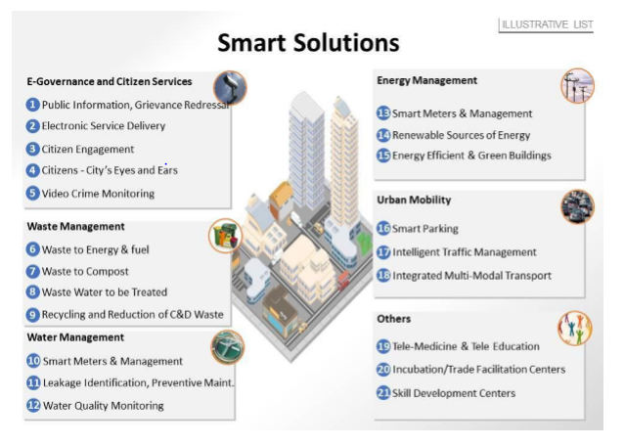

Accordingly, the purpose of the Smart Cities Mission is to drive economic growth and improve the quality of life of people by enabling local area development and harnessing technology, especially technology that leads to Smart outcomes. Area- based development will transform existing areas (retrofit and redevelop), including slums, into better planned ones, thereby improving liveability of the whole City. New areas (greenfield) will be developed around cities in order to accommodate the expanding population in urban areas. Application of Smart Solutions will enable cities to use technology, information and data to improve infrastructure and services. Comprehensive development in this way will improve quality of life, create employment and enhance incomes for all, especially the poor and the disadvantaged, leading to inclusive Cities. Accordingly, the purpose of the Smart Cities Mission is to drive economic growth and improve the quality of life of people by enabling local area development and harnessing technology, especially technology that leads to Smart outcomes. Area- based development will transform existing areas (retrofit and redevelop), including slums, into better planned ones, thereby improving liveability of the whole City. New areas (greenfield) will be developed around cities in order to accommodate the expanding population in urban areas. Application of Smart Solutions will enable cities to use technology, information and data to improve infrastructure and services. Comprehensive development in this way will improve quality of life, create employment and enhance incomes for all, especially the poor and the disadvantaged, leading to inclusive Cities.

**By Udaya Bhaskar Reddy Malkannagari:**

**Project Plan:**

**General Research on Smart Cities:**

**“the great enemy is complexity, measured in lines of code, or interactions.”**

**Smart Cities:**

**“What is a smart city?”** It’s a hard question to answer. “Smart” is a problematic word that has come to mean a million things. Soon, it may take its place alongside the handful of international cognates — vaguely evocative terms like “sustainability” and “globalization” — that no one bothers to translate because there’s no consensus about what they actually mean. When people talk about smart cities, they often cast a wide net that pulls in every new public-service innovation from bike sharing to pop-up parks. The broad view is important, since cities must be viewed holistically. Simply installing some new technology, no matter how elegant or powerful, cannot solve a city’s problems in isolation. But there really is something going on here — information technology is clearly going to be a big part of the solution. It deserves treatment on its own. I take a more focused view and define smart cities as places where information technology is combined with infrastructure, architecture, everyday objects, and even our bodies to address social, economic, and environmental problems.

**“what do you want a smart city to be?”**

We need to focus on how we shape the technology we employ in future cities. There are many different visions of what the opportunity is. Ask an IBM engineer and he will tell you about the potential for efficiency and optimization. Ask an app developer and she will paint a vision of novel social interactions and experiences in public places. Ask a mayor and it’s all about participation and democracy. In truth, smart cities should strive for all of these things.

Today’s cities are facing many common challenges in the areas of safety, mobility, emissions, accessibility, and congestion. Innovation is an important mechanism to pro-actively address the challenges facing cities and identify opportunities for new business models.

**“Challenges?”:**

The sheer size of city-scale smart systems comes with its own set of problems. Cities and their infrastructure are already the most complex structures humankind has ever created. Interweaving them with equally complex information processing can only multiply the opportunities for bugs and unanticipated interactions.

**Smart City Applications:**

**Open-data initiatives** and hackathons, like New York City's [BigApps](http://nycbigapps.com/) competition, which produce useful and resource-saving [apps to improve cities](http://mashable.com/2012/11/07/open-data-city-apps/) and keep citizens informed. Things like air quality, restaurant sanitation scores, building inspection scores and impending legislation should be readily available for all citizens.

**Environmental Monitoring** – a typical city has a handful of expensive monitoring stations for pollution or weather conditions, most of which cannot be monitored in real time. New systems are emerging that allow cities to monitor the environment with many more sampling points and in real time. This will help pinpoint the source of potential problems that can then be quickly and efficiently dealt with, as well as providing invaluable data for planning.

**Information Beacons** – enabled by Apple’s iBeacon and Google’s Eddystone, many city assets are now becoming location-aware information portals. New services are emerging that enable consumers to receive real time transport information or special offers from local businesses.

**Smart Street Lighting** – this has always been the leading smart city application cited by analysts due to its impressive early growth and clear business case. Smart street lighting is increasing its importance by reusing the lighting column as a communications hub.

**Smartphone Detection**  
Detect iPhone and Android devices and in general any device which works with WiFi or Bluetooth interfaces.

**Smart Roads**  
Intelligent Highways with warning messages and diversions according to climate conditions and unexpected events like accidents or traffic jams.

**Traffic Congestion**  
Monitoring of vehicles and pedestrian levels to optimize driving and walking routes.

**Carpooling or public transport enabling apps:**

**Smart Journey Planning** – we are seeing a growing number of systems that utilise open city data in order to suggest how individuals can best get from A to B. The systems are now becoming more sophisticated, taking into account personal preferences such as cost, safety concerns and CO2 footprint.

**Carbon Footprint** – Greenhouse gas emissions

**Transport Sharing** – city bike schemes, whilst great for flat city centres, don’t really work over large areas or in hilly communities. We are seeing the emergence of new bike sharing schemes that allow people to share access to better bikes that are not tied to a few expensive bike stations. **Electric vehicles**, this will be a key enabler for wider adoption of city centre car sharing.

**Smart Parking** – the initial focus of parking was on reducing congestion but this only had a clear business case in a limited number of cities. New advances are emerging that save costs whilst encouraging citizens to change behaviour in order to make city centres an enjoyable place to visit.

**Parking apps**

 that show drivers where the nearest available parking spot it. These will save commuters time, gas, emissions and money, while also easing the flow of traffic.

All-digital and easy-to-use [**parking payment systems**](http://mashable.com/2012/07/18/parking-tech/) — think EZ-pass for parking. We don't want to put receipts on the dashboard or be confined to time limits that make us run out to put more coins in the meter (if you're going to keep money meters, at least let us add money via an app). It's fine that you charge for parking, but improve the system.

**City guide app**, with information about museums, parks, landmarks, public art, restaurants and real-time traffic data.

**Traffic rerouting apps**

Widespread use of [**traffic rerouting apps**](http://mashable.com/2012/08/22/traffic-apps/), such as [Greenway](http://greenway2012.wordpress.com/) and [Waze](http://waze.com/). The average person spends 60 hours in traffic each year, according to Greenway; these apps calculate the best route for each driver to speed up traffic flow and reduce CO2 emissions. They also ensure that a traffic jam on one boulevard doesn't just get displaced to another area.

Dynamic kiosks that display **real-time information**, concerning traffic, weather and local news, like [Urbanflow](http://helsinki.urbanflow.io/) in Helsinki.

More public transit, **high-speed trains**, and bus rapid transit (BRT) to help citizens traverse the city with speed and low emissions.

**Wi-Fi**

in subway stations and on trains, along with weather information at every station

**Energy consumption monitoring systems and technologies:**

High-tech waste management systems Pay As you Throw (PAYT) garbage disposal would encourage people to recycle more and waste less, while using tools like RFID could improve sorting so recyclable plastic bottles don't end up in landfills.

**Smart Environment Apps:**

**Structural health**  
Monitoring of vibrations and material conditions in buildings, bridges and historical monuments.

**Noise Urban Maps**  
Sound monitoring in bar areas and centric zones in real time.

**Electromagnetic Field Levels**  
Measurement of the energy radiated by cell stations and and WiFi routers.

**Earthquake Early Detection**  
Distributed control in specific places of tremors.

**Snow Level Monitoring**  
Snow level measurement to know in real time the quality of ski tracks and allow security corps avalanche prevention.

**Potable water monitoring**  
Monitor the quality of tap water in cities.

**Swimming pool remote measurement**  
Control remotely the swimming pool conditions.

**Intelligent recycling disposal:**

The adoption of innovative and smart technologies can help increase efficiency and productivity in the waste management and recycling industry and reduction in the manpower and transportation costs.

**Waste Data Analysis:**

Smart technologies are being developed to help government officials in cities to better analyse and manage their waste data. An example is IBM Research, which partnered with the Nairobi City County using big data, analytics and mobile technology to develop a pilot program in mounting smart devices to the city's waste management trucks, so that they can collect data about the fleet, trucks and drivers, while also tracking problems on the roadways.  
  
The pilot program provided analytics-based indicators and alerts to improve the performance of the entire fleet and will help the city design a more efficient system for picking up waste. Besides the improvements to waste management, road blockages, accidents and potholes could also be reported back to city officials for tracking urban infrastructure more efficiently.

**Waste Bins and Collection:**

Innovative and smart technologies are also available for monitoring waste bins and optimizing waste collection. Wireless sensors are placed in waste bins that are able to measure how full a bin is, generate schedules and optimize routes for waste collection. Instead of waste collection trucks going to every location to collect waste on fixed schedules, regardless of whether the bins are full or not, the smart technology enables the waste collection company to better plan the utilization of manpower and trucks. This could result in increased efficiency and productivity, **reduced logistics costs** and **lower carbon emissions** from the trucks.

In **Singapore**, new HDB housing estates are fitted with Pneumatic Waste Conveyance Systems. These innovative systems efficiently convey waste by air suction through an underground network of concealed pipes to a central location. Odours, pest infestations and exposed waste will be reduced allowing residents to enjoy a more pleasant living environment. This process will also reduce the need for workers to collect refuse, as well as lessen refuse truck traffic.

**Intelligent remote monitoring with Smart Bins**

Features

* Container Intelligence
* Fill-level Sensors
  + Updating the wastage fill levels via a link protocols.
* Smart Bin live
  + Monitoring the Containers and planning optimized routes from anywhere

**Management of Specific Waste:**

**Example: Food, Plastic Waste**

 There can be **automated food waste tracking systems** to help food companies and restaurants monitor and reduce waste. The **food waste tracking system** typically includes **a built-in scale, camera, and a touchscreen user interface**. Before disposing food waste, employees would weigh the food, and a picture of the waste would be taken. Employees would record the type of food being thrown away and the reasons for its disposal. An **online reporting dashboard** will churn insightful charts to allow the company to view all their food waste and discover the most actionable opportunities to prevent wastage.

**Mobile apps** allow retailers to post unsold and edible food items for sale at a discount instead of throwing them away. Consumers can locate the nearest retailer on their mobile phone and enjoy the discounted food items. Other available apps allow retailers to launch a surplus food redistribution scheme, which allows food charities to register and receive food from the retailers, while the retailer will be able to centrally monitor what products are resulting in surplus and manage how this can be reduced.

**Billing the Customers:**

**Food Waste Disposal Bill:**

Residents have to deposit food waste into a special bin by scanning their card(like a radio frequency identification card for example) to open the bin lid. The weight of the disposed food waste amount is recorded and analysed via a wireless data system as the lid closes. The system accumulates the fee on a monthly basis and each household receives a monthly food waste disposal bill. The food waste is taken to sorting facilities, where it is converted to animal feed, fertiliser, or used to generate electricity.

**Plastics Waste:**

For plastics waste, the availability of innovative technologies such as an automated and advanced optical scanning technology can help in sorting mixed plastics into separate plastic streams for further processing into resins of higher purity, thus increasing the value of the recycled product. Other innovative technologies include the conversion of waste plastics into fuel using pyrolysis, where plastics is heated in the absence of oxygen and is broken down into liquid fuel, gases and solid char. The liquid fuel can be refined into a variety of different fuels such as diesel and petroleum.

**Task:**

**Interview:**

**Topic:** Transport Enabling Apps

**Demographic Info:**

**Quotes:**

“Life here is cool and easy!”

“It helps me almost daily!”

“Oh…it was not a pleasant experience!”

**Age: 21**

**Gender: Female**

**Occupation: student IT**

**“Hello, Good morning! How are you?”**

“I am fine, Thank you! How are you? “

**“I am doing good as well, and thank you for giving me the time to interview u.”**

“Not a problem!”

**“How long have you been in Singapore?”**

“Ah…for almost a year!”

**“What do you like the best about Singapore?”**

“It’s a tough question to answer, really! Because there are so many things I like here. I cannot single out one particular thing. But life here is cool and easy!”

**“You say easy, can you elaborate on that a bit more? Is there anything particular you were referring to?”**

“Ah, yes! When I said “easy”, I used it in a more general way of speaking. I only meant everything is more streamlined here.”

**“What do you think about the transportation system here? For example, the ease of travel, like using a bus service or an MRT.”**

“I think the transportation system is great. It has saved me a lot of time. I usually take a bus every morning from my home to school, and the transport apps are of great help. It saves me a lot of time just checking the bus timings on my mobile, and reaching my destination on time.”

**“Can you tell me about any particular instance when using these transport apps helped you?”**

“It helps me almost daily! But I can recall an incident when I was new to school here. I did a diploma in web design and wanted to work on some freelance projects to gain experience. I asked one of my instructors to help me find a good project to work on. One day I received a message from my instructor that I have to attend a meeting in half hour to discuss about my project with a senior consultant working for a top MNC. He texted me the meeting place and time. I was unprepared but I cannot afford to miss out on that meeting.”

**“Please continue…”**

“I wanted to call a cab but my credit card was showing an error for some reason. I had no cash on me at that time, I already spent it all on shopping that day. I only had the EZ link card I use for public transit. And it was really helpful. I searched for the bus route and my destination. I knew the exact timing the bus would arrive at the nearby Bus station. I walked to the Bus station, spotted the bus immediately and I was able to reach to my meeting point on time.”

**“That’s really nice to hear. How did the meeting go?”**

“It went really well. I got assigned to work on a sub-project for the company. The transport app saved the day for me.”

**“Sure, it has! Can you think of any improvements you would like to see in these transport apps?”**

“Yes, I would like to see some additions. Especially when it comes to knowing the exact bus route to an exact location. Because I don’t want to constantly check my mobile to locate my destination. If they can provide free wifi inside the bus, it will be of great help. Otherwise, they can have a real-time screening system inside the bus to monitor our current location on the GPS.”

**“That’s a good idea, I am sure it will be implemented in the days to come. Now that we have talked about the transportation system here, can you tell me your opinion on how to improve the overall transport and road system here.”**

“Hmm…I am not sure if its related, but if we can have some good apps that will provide us with information about parking spaces, I think they will be very useful. Because last week, we went to a movie and couldn’t find a proper parking space for two hours. We almost missed the show!”

**“Can you narrate to me how it all happened?”**

“Oh...nothing much in it. A group of our friends planned to watch a movie during the weekend. We booked the tickets and drove to the cinema. But we couldn’t find any parking space available. We were directed to another place to park our car, but there was a long queue of vehicles…traffic jams…oh, it was not a pleasant experience. We had to wait for more than an hour before we could park our vehicle. We almost missed the show. I wonder how such things will affect us in case of an emergency!”

**“Yeah, I can understand. Can you make any suggestions to improve the current parking system?”**

“I think it should work like the bus transport system. There must be apps that will allow us to see the parking spaces readily available in real time. So that we can easily pick one of the parking spaces available. We don’t have to hunt for spaces, it will save us a lot of time and effort.”

**“You are right, How do you think such a system would benefit you as a user?”**

“Firstly, it will save me a lot of time. Secondly, We don’t have to face disappoints like missing out on a movie or our plans going haywire in the last minute over not finding a parking space. Sometimes our whole family outing may get ruined because of wasting time over searching for a proper parking place. I personally think these issues need to addressed on top priority. With the current advances in Information Technology, i think it is much easier to create an interlinking mechanism that will help the normal public save time.”

**“What other suggestions can you make with regards to improving the current transport system in Singapore?”**

“Not many, but the overcrowded trains have always been a problem for me. And I cannot imagine the plight of older people or pregnant women using an MRT during peak hours. That problem needs to be addressed.”

**“How do you think it should be addressed?”**

“Sorry, I am not sure about it.”

**“That’s alright! I think you have made quite a lot of insightful suggestions for user sustainability when it comes to transport system here in Singapore. Thank you for giving me your valuable time. It was a pleasure speaking with you.”**

“I am glad I could be of help. It was nice talking with you as well. Have a nice day!”

**Interview notes:**

Interview Date: 27-08-2016

Interview Time: 10.30 AM

**Personal details**:

**Age:** 21

**Gender:** Female

**Occupation:** Student, IT

**Interesting stories**:

The most interesting story was when she narrated about her personal experience while using the bus transport app, and how it helped her secure a job.

**Motivations**:

Feel in control of her day.

Always emphasizes on the time factor.

Likes to get things done on time.

Likes to go out with people to spend time.

Wants a user friendly Environment.

**Frustrations**:

The parking information is not real time.

Overcrowded trains bother her.

**Interactions:**

Uses smart phones off the clock to access data.

Works on many projects at once.

Lifestyle is hectic, has to attend classes and finish her work as a freelance web designer.

Maintains a fine balance between work and school.

**Remaining Questions**:

I would like to ask her about Smart Roads and how this technology can be useful in making a sustainable environment more user friendly.

**Project Plan:**

1. **Point of View Madlib:** The user needs a solution to the parking problem because she feels it can save her a lot of time.
2. **Point of view Madlib:** The user needs a solution to the overcrowded train network because she finds it hard to use it during peak hours.

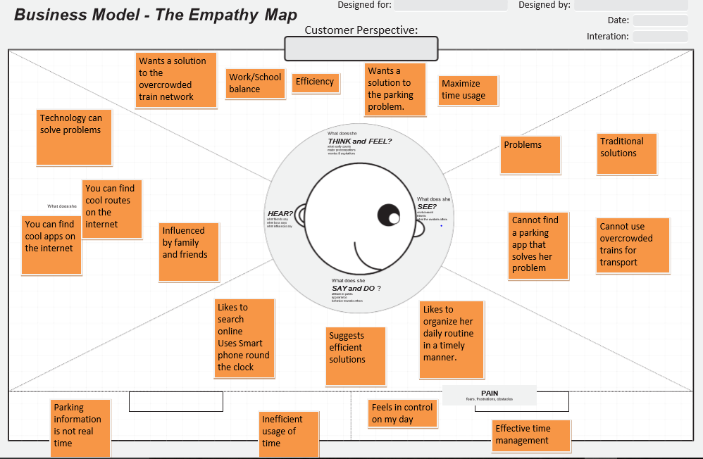

**Research notes and insights (based on the interview):**

**Secondary Research Notes:**

|  |  |  |
| --- | --- | --- |
|  | **Source:** | **Insights:** |
| **1** | **Parking app**  [**https://vulcanpost.com/465722/app-parking-lots-prediction-singapore/**](https://vulcanpost.com/465722/app-parking-lots-prediction-singapore/)  The app is the first product developed by Singapore’s Intelligent Transport Systems Lab, which was jointly created by the government’s Institute for Infocomm Research, the Technical University of Munich and German car parts manufacturer Continental.  https://govinsider.asia/smart-gov/singapore-transport-lab-develops-smart-parking-app/ | “The Park&Go @SG app” was developed with the help of the Housing & Development Board (HDB) as well as the Land Transport Authority (LTA), the app will include a database of carparks in residential areas.  Continental Automotive Singapore an international automotive supplier and technology company — launched this mobile app that helps drivers locate carparks and navigate to them. |
| **2** | Android Train app - [Planner Xtra](https://play.google.com/store/apps/details?id=nl.ns.android.activity&hl=en) -- from Dutch [national train operator NS](http://en.wikipedia.org/wiki/Nederlandse_Spoorwegen) (Nederlandse Spoorwegen, the principal passenger railway operator in Netherlands) <http://www.wired.co.uk/article/train-crowds-app> | Train app lets customers see how busy carriages are before boardingLets passengers know how crowded trains they plan to catch are, updated in realtime. |
| **3** | **Parking Sensors – PARKER app**  **http://www.govtech.com/transportation/5-Mobile-Parking-Apps-to-Help-Cities-Ease-Traffic-Congestion.html**  **http://www.theparkerapp.com/** | Parker is a mobile app that takes the guesswork out of parking with a space locator, voice navigation and timed notifications to prevent tickets. The app accomplishes all this by partnering with cities to install **RF sensors** beneath parking spaces, a mechanism that detects the status of open or closed spaces. |
| **4** | **Beat the Traffic – mobile app**  **https://en.wikipedia.org/wiki/Beat_the_Traffic** | A mobile app that constantly monitors traffic with real-time updates.  Features include:   * Color-coded traffic map showing areas of congestion * Personalized routes, enabling a one-click access to most driven routes’ traffic conditions * Live traffic cameras * Text or mail notifications informing about delays on preferred routes * Incidents reports |

**Ideating a solution to the user problem:**

There is nothing like getting stuck in a long line of traffic, or waiting for hours to park your car, or unable to get a standing space in an overcrowded train, at the start of your day, especially when you have places to be and appointments to keep. One 2011 [IBM](http://www.forbes.com/companies/ibm) **IBM -0.20%**study found that 30 percent of a city’s traffic is attributable to people hunting for parking — with a third of New York City drivers reporting they search for 20 minutes on average. It is an everyday problem that needs to be addressed on a high priority basis.

There are multiple ways we can address these problems. For the parking problem, we can use the aid of smart phone mobile apps to give real-time updates to the commuter about the status of available parking lots. We can accomplish this by putting sensors beneath the parking spaces to detect the status of an open or a closed parking slot. We can create an integrated parking network system, with the aid of Government and private corporations, in assisting and delivering to the needs of the commuters.

Reaching a destination can also be interlinked when trying to solve the parking space problem. This is caused by the traffic congestion that a commuter has to face in their everyday life. One of the best ways to solve this is to provide prior information to the commuter about the traffic congestion on a certain route. This can be accomplished with the use of mobile apps that constantly update and monitor traffic routes.

And if the commuter wants to use another kind of transportation, like trains, it is essential to provide information about the level of congestion before boarding the train.

Creating such simple, user-friendly mobile applications will open up many new possibilities and transform how we live and work, making sustainable living more accessible than ever.

**By Frederike Pia Lutz:**

**Interview**

**Topic:** Transport in Singapore – experience and suggestions / ideas

**Demographic Info:**

**Age: 24**

**Gender: Female**

**Occupation: International student at JCU Singapore**

**“Hello, good morning! Thanks for participating in this interview today. I hope you are feeling well today.”**

“Sure, no problem. I am good, thanks. “

**“How long have you been staying in Singapore and what are you doing here?”**

“I’ve been living in Singapore for almost four months and will be here for two years total, finishing my bachelor’s degree at the JCU.”

**“What do you like the best about Singapore?”**

“I like many things about Singapore…. But mainly that everything is easy and ordered, everything works fine.”

**“What do you mean by ‘easy’? Do you mean the people or the lifestyle, or…?”**

Tough question, but if you want an example, the MRT service. It really is easy to travel, no delays, nothing compared to how it is in Norway or Europe for example. The transportation system is great, it saves a lot of time and the transport apps you can download for free are a lifesaver, especially if you haven’t been here long and need help to orientate yourself.”

**“You mentioned the transport apps. Can you tell me more about when and how you use these?”**

“I use them daily! In the beginning more, of course, because I didn’t know where to go and how to get to school and to my gym, to meet my friends for coffee, etc. But I still use it today. Sometimes I don’t know how to get somewhere, other times a bus station might be close due to constructions, so I need to find an alternate route. One time it was great: I was out with a friend of mine and I forgot that in Singapore the last trains are around 11pm. I arrived at the MRT station at 11.30 and they actually had an announcement that this was the last train for the day so I hurried up and actually just caught the train in time! That was great because I didn’t have to pay for the cab fare!”

**“Can you think of any problems and ways to improve those”?**

“Yes, actually what I just mentioned. For once, it would be nice if the trains would not stop around 11pm or midnight. Especially because they’re not driven by people but automatically I think, they could run longer. And even though the transportation apps are great, it would be best if they could show when the last train is since they don’t follow a certain plan: sometimes the last train is at 11pm but sometimes you catch a train at 11.30 pm. If you miss the last train it is really bad if you live far away and have to pay a lot of money for the cab. Additionally, it would be nice if the apps would give an indication of how crowded the trains are during rush hour. This morning for example, I went to school around 8.30 and it was so crowded that I had to wait almost 15 minutes until I was able to board the train. Fortunately, I didn’t have a class until 11 so I wasn’t late, but if I had had a meeting I would have needed to leave earlier than I normally do and since I didn’t have a meeting, I could have stayed at home longer and wait for the crowds to pass.”

**“That is a good idea! Do you have any idea how to implement that?”**

“Well, maybe one could implement a traffic-light-system in the apps. For example, if the train is not crowded it gets a green light, for crowded a yellow light and if it is too packed a red light, so passengers know that they don’t have to bother to catch that train but that it would be wiser to wait for the next or leave earlier because they might need more time to get to the destination.”

**“Are there any more suggestions you have for the traffic system in Singapore based on your experiences?”**

“Not too many besides the ones I just mentioned, because, as I already said, the traffic system is exceptional I think. I really think the indicator of how crowded the trains are would be an immense help to everybody, and maybe one could expand that to stations and busses as well. And what I think is absolutely necessary is to have an idea of when the last train is coming and maybe extending the operating hours of the trains, especially on nights when there are concerts and parties and on the weekends of course, since many people are going out then. I have no experience with cars because I am not driving here.”

**“Thank you very much for your insights…”**

“Wait, sorry! There actually is another thing I would want to improve if I could!”

**“Sure, no problem, go ahead!”**

“I haven’t taken a cab often so far, but quite a couple of times. The driver never knew where to go, I always had to pull up Google maps on my phone and tell him where to go. This is something I am not used to at all. Normally taxi drivers know every street in a city. So one might create an app for taxi drivers, so they can find the way, because I have just moved to Singapore, and if I take a taxi I do because I don’t know the way myself most of the times. And maybe the same app could tell potentially passengers where to find the next taxi stand and how many eligible taxis are there so one knows where to go if one needs a taxi”.

**“That’s a great idea, thanks! Thank you for your time and suggestions, I am sure they will be a great help. I hope you have a good day and enjoy your time in Singapore.”**

“Thank you!”

**Interesting stories**:

* Being an international student from Norway in Singapore
* Being able to provide the insights of a different country and culture into this interview

**Motivations**:

* Timely, smooth travel
* Enabling an easy journey not only for herself but for other passengers as well
* Improvements in travel apps and customer services

**Frustrations**:

* Overcrowded trains and stations
* No real-time information
* Taxi drivers who might need some extra help with orientation to enable a passenger transfer
* No reliable information about the last train at night
* Trains without drivers could and should operate longer
* No overview of the availability of taxis

**Interactions:**

* JCU students, national and international
* Norwegian boyfriend
* Small Norwegian community (friends and distant family living in Singapore)

**POV madlib:**

A Norwegian girl wishes for an improved and more efficient traffic system, from trains to buses, taxis and the corresponding assistance (e.g. apps) with relatively easy and innovative means since it is crucial to use one’s time effectively, not waste it on unnecessary and avoidable tasks and it is highly recommendable to organize a great number of people living in a rather constricted area in the most efficient way possible.

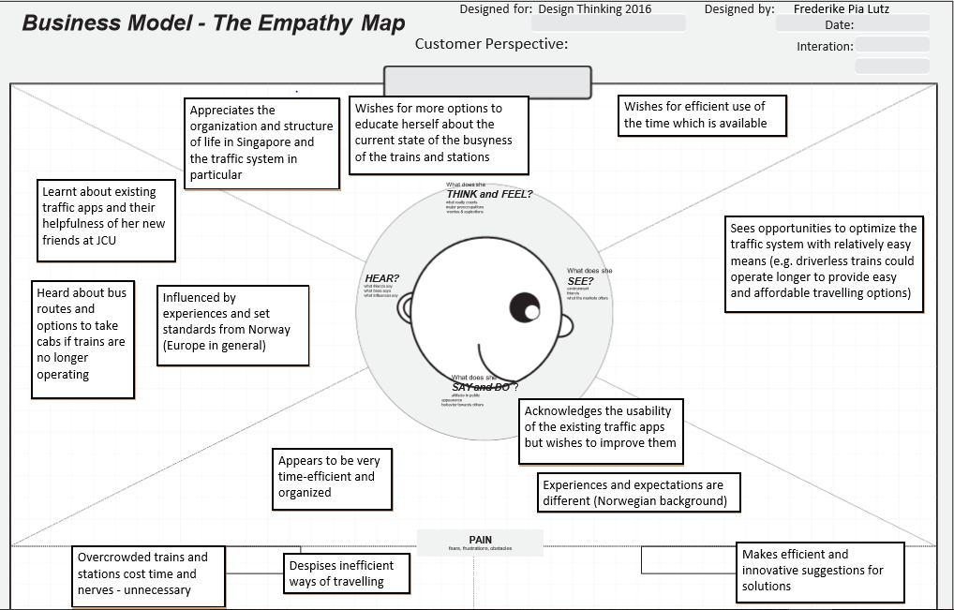

Secondary Research Notes:

|  |  |  |
| --- | --- | --- |
|  | **Source:** | **Insights:** |
| **1** | Samsung smart things, http://www.samsung.com/uk/smartthings/ | A smart hub is used by Samsung to control different appliances at home, one of their objective is to create a safer home |
| **2** |  |  |
| **3** |  |  |
| **4** |  |  |